**Watermark in motion vectors – part 2**

**1. In orginal paper, they propose watermark embed method based on H264 encode motion vector direction.**

- Watermark extract process

In original pater, in fixed block, if motion vector set to left direction, Watermark is 1, if set to right direction, Watermark is 0.

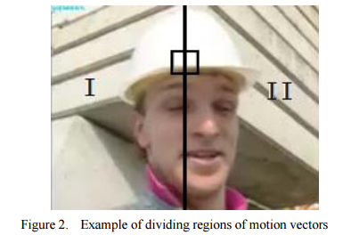

- Watermark embed process.

In order to enable above extract watermark, they have changed motion vector algorithm as follow in H264 codec.

In other words, they restrict search region of microblock which embedded watermark.

- In this case:

the case that the matching macroblock was in the left region of current macroblock indicates 1. And 0 can be embedded if the matching macroblock was in the right region of current macroblock. But there will be a special case that the current macroblock can’t find a good matching macroblock in the region we restrict. In this case, the bit rate will increase more, and the video quality is likely to decrease. So if the case occurs, the intra mode can be used instead of inter mode.

**2. Your propose method**

But in your proposal method, instead of using same position micro block between sequence two frames, first Perform subtraction between selected frames (frame y – frame x) and calculate MSE in each block.

And then Calculate MSE (mean square error) between all 8x8 blocks in the selected frames and Sort the MSE results from the maximum MSE to the minimum MSE, divide the range into 3 levels

1) Error1

In general, watermark must be embedded into region which have many change, so that PSNR and Bitrate can be reduce, but you have propose to embedded watermark which have small change. so that PSNR and Bitrate may be increase much.

2) Error2

Motion vector information is meaningful when selected two frames connected closely, the more longer, meaningful lost.

And In H264 Algorithm, motion vectory must be calculated surely between neighbor frames, but you propose to select two frames randomly and calculate MSE.

3) Error3

In original paper, matching block search region is divided two region: left and right. only when predicted motion vector region is different from real motion vector region, encode mode is changed to intra mode. This method have informal, meaningful, mathematical feasibility.

But you divided search region into 8 sub region, in this case, there are many cases which predicted motion vector region is different from real motion vector region, and you have not propose intra mode algorithm overcome this issue.